Mosman Park Primary School Reconciliation Action Plan (RAP) 2020
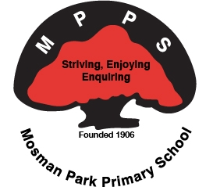
Our school has worked with the staff, broader community and our Aboriginal families to create a vision statement for Reconciliation and have committed to a series of actions in order to support this in our school. Our purpose is to develop an environment that fosters a higher level of knowledge and pride in Aboriginal and Torres Strait Islander histories, cultures and contributions.
Vision:
LISTEN
For the benefit of all, celebrate, embrace and take pride in the richness of Aboriginal cultures/stories
LEARN
Acknowledge past wrongs and move forward; deepening understanding and valuing of Aboriginal cultures, heritage and connection to country/land
LEAD
Creating opportunities for respectful and equitable cultural partnerships within our community and beyond, by embedding knowledge of our Noongar geography, culture and language
TRUTH, JUSTICE, HEALING

RAP Actions
RELATIONSHIPS
Relationships in the Classroom
- Aboriginal and Torres Strait Islander People in the Classroom*
- Opportunities for Aboriginal and Torres Strait Islander Students & Children
Relationships around the School
- Elders and Traditional Owners Share Histories & Cultures
- Cultural Competence for Staff*
- Reconciliation Projects
Relationships with the Community
- Welcome to Country*
- Celebrate National Reconciliation Week*
- Build Relationships with Community*
- Family Community Room

RESPECT
Respect in the Classroom
- Teach About Reconciliation*
- Teach About Days of National Significance
- Explore Current Affairs and Issues*
Respect Around the School
- Acknowledgement of Country*
- Care for Country
Respect with the Community
- Aboriginal and Torres Strait Islander Flags*
- RAP Launch (with school song)
- Take action Against Racism *

OPPORTUNITIES
Opportunities in the Classroom
- Embed Cross-curriculum Priority- School Specific
- Curriculum Planning*
Opportunities Around the School
- Inclusive Policies*
- Staff engagement with RAP*
Opportunities with the Community
- Local Sites, Events and excursions
- Celebrate RAP Progress*
- Aboriginal & Torres Strait Islander Languages

